**2.1 transmission media and bit streaming**

**Name _____________ class______________**

1. Write down five signal transmission media, do not look at the following parts.
2. (a) Give **three** benefits of fibre-optic cable over copper cable.

(b) Give **two** benefits of copper cable over fibre-optic cable.

Advantages of copper cable

Advantages of fibre-optic cable

1. Three methods of connecting devices include fibre-optic cables, copper cables and radio waves. The table below gives descriptions relating to these connection methods.

Tick (✓) one box on each row to show the method that best fits each description.

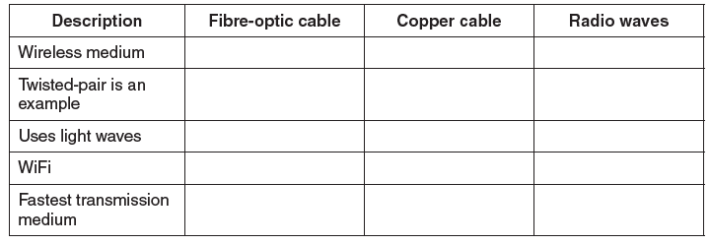

3. (a) Explain the term bit streaming.

___________________________________________________________________

___________________________________________________________________

___________________________________________________________________

(b) A person watches a film streamed from a website on a tablet computer.

**(i)** Give **two** benefits of using bit streaming for this purpose.

___________________________________________________________________

___________________________________________________________________

___________________________________________________________________

___________________________________________________________________

**(ii)** State **two** potential problems of using bit streaming for this purpose.

___________________________________________________________________

___________________________________________________________________

___________________________________________________________________

___________________________________________________________________

**(c)** Explain the terms on-demand bit streaming and real-time bit streaming.

___________________________________________________________________

___________________________________________________________________

___________________________________________________________________

___________________________________________________________________

___________________________________________________________________

___________________________________________________________________

___________________________________________________________________

___________________________________________________________________

___________________________________________________________________

1

– fibre optic cables have greater bandwidth

– fibre optic cables need less signal boosting // can transmit over longer distances

– fibre optic cables have greater security (more difficult to “tap” into)

– fibre optic cables are immune to electromagnetic and other effects

– fibre optic cabling is lighter in weight (easier to install)

– fibre optic cables consume less power

– copper cabling is less expensive to install

– copper cable is easier to install because it is more flexible

– it is easier to make terminations using copper cabling

– the expertise in use of copper cabling is more extensive

– has been around for years … so very little is “unknown” about installations using this type of cabling

2

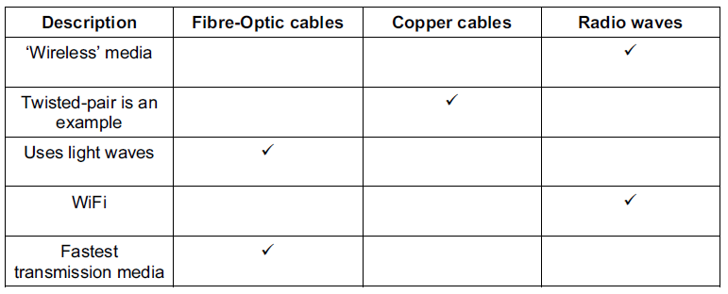

3

(a) any two from:

– sequence of digital signals / bits

– over a communication path / Internet

– transfer of data at high speed

– requires fast broadband connection

– requires some form of buffering

– bits arrive in the same order as sent [2]

(b) (i) any two from:

– no need to wait for a whole file to be downloaded

– no need to store large files on user’s computer

– allows on demand playback

– no specialist software is required for playback in browser

(ii) any two from:

– video stops / hangs if very slow Internet / broadband speed low

– video stops / hangs if inadequate buffering capacity

– loss of Internet means can’t access films / files

– may require specific software to run the files / films

– viruses can be downloaded from the websites

(c)

on-demand

– digital video tape, analogue video tape, or digital files are converted to bit streaming

– format for broadcasting on the net; this is known as encoding, these encoded streaming video files are then uploaded to a dedicated server

– a link for the encoded video is placed on a web site

– a user clicks on the link to download the encoded streaming video; the streamed video is

– then broadcast to the user as and when they require it

– can be paused / can go back and re-watch / fast-forward, etc. real-time

– an event is captured live with a video camera

– the video camera is connected to a computer

– the video signal is converted to streaming media files (encoded) on the computer

– the encoded feed is then uploaded from the computer to a dedicated streaming server via cable, DSL, or a high-speed internet connection

– the server then sends the live images it to all users requesting it as real-time video

streaming

– cannot be paused etc.